PRODUCT DETAILS

**Guess Watch GW0012G2**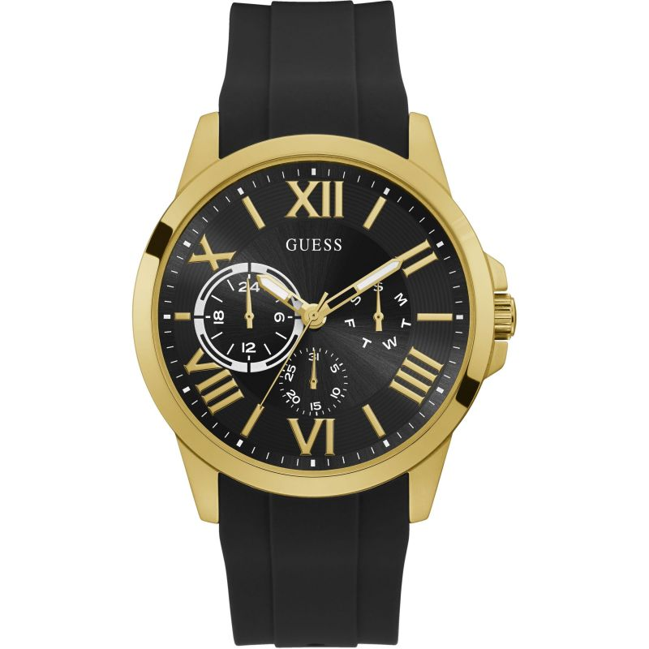

**£139.00**

**Specifications**

**Brand**: Guess

**Analogue/Digital**: Analogue

**Case depth approx**.: 10.00mm

**Primary Material**: Stainless Steel

**Case Shape**: Circle

**Case width approx**.: 46.00mm

**Clasp type**: Strap buckle

**Dial Colour**: Black

**Gender**: Gents

**Model Name**: Orbit

**Movement**: Quartz

**Strap colour**: Black

**Strap Type**: Rubber Strap

**Water Resistance**: 50 metres

**BARCODE**: 091661511455

**Guarantee**: 2 years